Finance Analytics Report

In the Finance Industry , a lot of decisions are made by consulting expert Analysts and its validity is tested multiple times before actually implementing it.

Variables accounted for our Analysis are :

Company registration number.
CompanyNumber
CompanyName
SICCode_SicCode_1
Debtors
CreditorsDueWithinOneYear

CashBankInHand

PersonEntChgName

Description
Name of the company.
Identify which area of industry thi business operates.
Debtors value taken from the financial accounts.
People/business who the business has to pay back money for goods or services or loans within a year.
Cash in hand or at the bank taken from the financial accounts of the company.
Bank/person who lent the company money or took out the charge on the company.
Type of charge registered.

With this type of data in hand and with favourable number of records , we take a deeper look into how the data can provide Insights.Data Analytics gives us numerou approaches towards understanding different patterns within any given data.From this data , we observe

 | Debtors | CreditorsDueWithinOneYear | CashBankInHand
1 | 1760305 | 1294833 | 157795
2 | 148924 | 177105 | 10154
3 | 386104 | 321764 | 40928
4 | 276045 | 203015 | 4740
5 | 80631 | 70597 | 5589
6 | 100455 | 134662 | 32682
7 | 283543 | 281284 | 14315
8 | 33178 | 25193 | 31
These three variables are our prime concern for each company under the influence of a given bank.

We have approximately 60 observations having the above records given, as an Analyst our objective is to extract useful insights from this data.
A very reliable way is to group the companies in separate clusters, each cluster represent all banks as given.

The banks concerned here are :

BIBBY FINANCIAL SERVICES LIMITED
HSBC BANK PLC
LLOYDS TSB COMMERCIAL FINANCE LIMITED
RBS INVOICE FINANCE LIMITED

The Clustering algorithm we have used here is called K-Means Algorithm and is Statistically implemented on this given data using R Programming Language.The objective is to form clusters on the basis of common behaviour between the companies.we focus on the three variables :

Debtors, CreditorsDueWithinOneYear and CashBankInHand

The output will produce 4 clusters

K-means clustering with 4 clusters of sizes 18, 1, 31, 6

Cluster means:
Debtors CreditorsDueWithinOneYear CashBankInHand
1 244621.7 248586.9 49489.11
2 1760305.0 1294833.0 157795.00
3 53023.1 71355.0 19910.06
4 515789.0 479904.5 48039.67

The number of companies in each cluster can be depicted as

CLUSTERS 1 2 3 4
BIBBY FINANCIAL SERVICES LIMITED 2 0 6 0
HSBC BANK PLC 3 1 4 1
LLOYDS TSB COMMERCIAL FINANCE LIMITED 8 0 19 3
RBS INVOICE FINANCE LIMITED 5 0 2 2

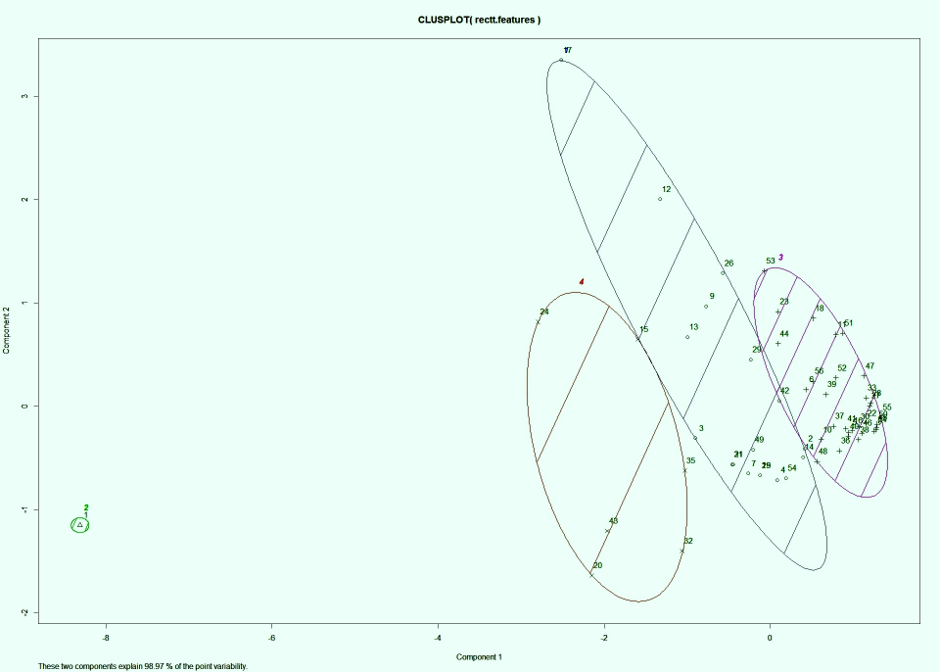

The number of debtors, Creditors and CashBankInHand of a company will give an idea about its type and scale,and that would go on to define the parameters for a cluster. So when in future,one gets to know the number of debtors, Creditors and CashBankInHand of a company in a certain year or over a period of few years,immediately it can be placed in a certain predefined cluster and “IMMEDIATE INSIGHT” about the scale and reach of that new company can be gained.

A bank with this type of analysis can easily target those companies which are more profitable for them and stay ahead of competition.

It can form a basis on which a company can be objectively parameterized as also it will form the groundwork for further analysis like whether the company is borrowing money greater than its reach.

